Creating the Most Ideal Gambling Solution

#### **Introduction**

Any man or woman who aspires to make a super casino device ([카지노 솔루션 제작](https://www.solutionfactorys.com/)) want to have massive facts in gaming and need to be well-versed with modern technological tendencies. When advanced properly, such structures can make sure that clients are entertained whilst at the same time making artwork simpler for operators. This article highlights some of the components important for growing an awesome casino solution and the way it advantages the enterprise.

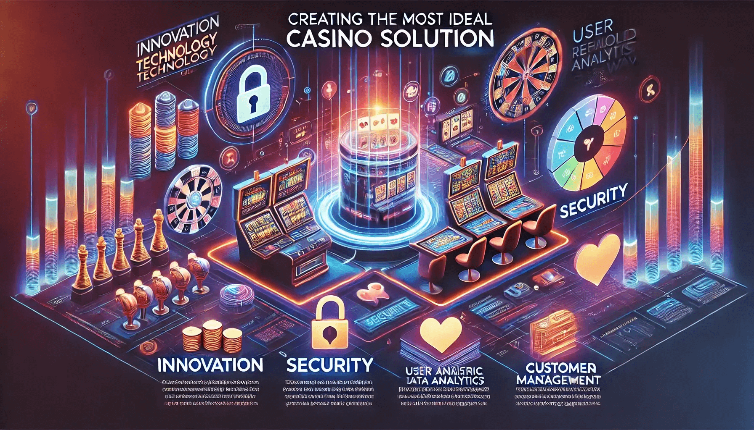

#### **Essential Elements of a Casino Solution**

1. **User-Centric Design**:
   * The basis of all a success casinos solutions (카지노 솔루션 제작) lies of their client-centric designs which contain growing interfaces which can be intuitive sufficient for clients’ desires. Navigation should be easy so should loading times plus there should also be some interactive features which will keep players hooked onto them.
2. **Robust Gaming Portfolio**:
   * Variety is key when it comes to any good gambling platform because people have different preferences; therefore, there should be provisions made catering for this fact. A wide selection ensures everyone finds something interesting while high-quality games guarantee repeated visits by gamers thus leading to increased revenues over time.
3. **Advanced Security Protocols**:
   * The security of any gaming facility can never be underestimated considering that many people entrust them with personal information such as credit card details among others (카지노 솔루션 제작). Therefore robust security measures need to put in place during creation so that both data privacy and financial transactions remain safe always. Some examples include encryption technology adoption, use secure payment gateways or even having real-time fraud detection systems within these establishments.
4. **Comprehensive CRM System**:
   * Customer relationship management is crucial if you want your customers coming back satisfied each time they visit because it makes sure their individual needs are taken care of accordingly ([카지노 솔루션 제작](https://www.solutionfactorys.com/%EC%86%94%EB%A3%A8%EC%85%98%EC%86%8C%EA%B0%9C)). This can be achieved by integrating this software into casinos where one can track customer behavior, preferences and interactions thereby enabling targeted promotions creation based on such data among other benefits like personalized offers generation or even better customer support provision.
5. **Seamless Payment Integration**:
   * A successful gambling institution needs to provide an efficient payment system which will enable clients make quick deposits as well as withdrawals without experiencing any delays whatsoever during their stay there (카지노 솔루션 제작). Therefore the chosen casino solution must have various options for payments including credit cards, e-wallets and even cryptocurrencies so that everyone finds something convenient for them. Additionally, ensuring fast transactions coupled with secure channels fosters trust among users leading to higher levels of satisfaction from using such establishments.

#### **Benefits of a Custom Casino Solution**

1. **Enhanced Player Retention**:
   * When players feel catered for at all times while playing through intuitive interfaces then they tend coming back frequently hence increasing customer loyalty towards these businesses over time (카지노 솔루션 제작). Personalized offers could also contribute greatly towards this because people love being treated uniquely basing on their previous gaming experiences in similar places thus making them want more from what you offer next time round.
2. **Operational Efficiency**:
   * Administrative costs eat up most profits made by operators hence they should find ways of reducing these expenses if possible through automation or integration among different systems used within such casinos since it helps save lots of money meant for salaries etcetera which can be directed towards game development activities instead as well as engaging players more frequently too (카지노 솔루션 제작).
3. **Design and Development**:

* The on line casino solution (카지노 솔루션 제작) have to be tested fastidiously for great guarantee before it’s launched. Functional checking out ought to be accomplished; protection testing ought to also be carried out among different varieties of check like performance checks. Any identified issues in the course of this segment ought to be fixed at once therefore ensuring smoothness thru error-unfastened launching.

1. **Testing and Quality Assurance**:

* The casino solution (카지노 솔루션 제작) have to be examined carefully for first-class guarantee earlier than it’s launched. Functional trying out need to be achieved; safety testing should also be done amongst other forms of test like performance tests. Any diagnosed troubles at some point of this section must be fixed right away for this reason ensuring smoothness thru errors-free launching.

1. **Deployment and Support**:

* After successful completion of tests, deploy the casino solution (카지노 솔루션 제작). Ongoing support and maintenance are needed for addressing any post-launch issues as well as keeping up-to-date the industry standards or trends with current technology in use by similar businesses or organizations like yours.

#### **Conclusion**

In order to make a good casino app (카지노 솔루션 제작), it is necessary that one has deep knowledge about gaming industry coupled with incorporation of most recent technological advancements available today. Consider focusing on security aspects such as robustness against hacking attacks besides making use of customer relationship management tools which cover all areas comprehensively including payment gateways integration points seamless enough needed for better player experience while at same time enhancing operational efficiency leading even more success being realized within establishment concerned itself with gambling activities around its premises or online platform where people can play different games offered there at any given time.